PROJECT REPORT
on
Project Title
BATCH-2024
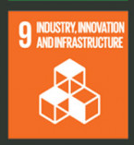

Project Mentor Student Name & ID
1.Piyush Kumar (2411981413)
2.Pramod Kumar (2411981420)

Project Title

- Introduction
  - Objective
  - Technology Stack
- Project Description
- System Architecture & Design
  - High-Level System Architecture
  - Detailed System Design
  - UML Diagrams
- Database Design
  - ER Diagram (Simplified)
  - Relationships
- Data Flow Diagrams (DFD)
  - Level 0 DFD (Context Level)
  - Level 1 DFD
- Features Implemented
- Screenshots
- Challenges Faced
- Pending Tasks
- Conclusion
- Appendix

Project Report: MERN Stack Web Application
Project Title: ProductForge: Cloud-Based Digital Product Marketplace and Lifecycle Management Platform

1. Introduction
The rapid growth of software development and digital entrepreneurship has increased the number of digital products available through the internet, including Software-as-a-Service (SaaS) applications, APIs, plugins, browser extensions, developer tools, templates, and downloadable software. Developers, independent creators, startups, and organizations increasingly rely on online platforms to distribute these products and provide services to customers.
However, managing a digital product involves significantly more than publishing a product page. A creator may need to manage product information, pricing, product files, releases, version history, payments, customer access, updates, reviews, and product performance. These activities are often handled using different systems, resulting in product information and management activities being distributed across multiple platforms.
Traditional digital marketplaces primarily focus on product discovery and transactions. Other platforms may specialize in software releases, payments, storage, analytics, or customer communication. Although these services are useful individually, creators may need to maintain information about the same product across multiple systems.
ProductForge is proposed as a cloud-based digital product marketplace and lifecycle management platform that provides a centralized environment for managing software-based digital products. It combines marketplace functionality with product management, release management, cloud file distribution, commerce, customer access control, reviews, analytics, and lifecycle tracking.
The platform considers the digital product as the central entity. A product can progress through different lifecycle stages such as Draft, Beta, Published, Updated, and Archived. Multiple releases of the same product can be maintained while preserving release information and customer access.
Creators can use ProductForge to publish products, configure pricing, upload releases, manage versions, monitor customers, and analyze product performance. Customers can discover products, purchase or subscribe to them, access eligible product releases, receive updates, and provide reviews.
The proposed system aims to reduce fragmentation in digital product management and provide a structured platform capable of supporting a product throughout its commercial lifecycle.

1.1 Objective
The primary objective of ProductForge is to design and develop a cloud-based full-stack platform that provides centralized management of software-based digital products throughout their lifecycle.
The project aims to provide an environment where creators can manage their products from initial creation and publication through commercialization, customer distribution, updates, and lifecycle management.
The specific objectives of ProductForge are:
- To provide secure user registration, authentication, and role-based authorization for creators, customers, and administrators.
- To allow creators to create, edit, publish, update, and archive digital products.
- To provide a centralized marketplace through which customers can discover and explore software-based digital products.
- To maintain multiple versions and releases of a product along with release notes and changelogs.
- To provide cloud-based storage and controlled distribution of product files and media.
- To support product monetization through one-time purchases and subscription-based pricing models.
- To maintain customer entitlements so that product access can be controlled according to purchases and subscriptions.
- To provide customers with a personal product library containing products and releases they are authorized to access.
- To provide ratings and reviews for customer feedback.
- To provide creators with analytics related to product views, downloads, purchases, customers, and other relevant events.
- To provide notifications for important events such as purchases and new product releases.
- To maintain a structured lifecycle history for each product.
- To design the system using a modular architecture that can be extended as requirements increase.
1.2 Technology Stack
ProductForge uses modern web and cloud technologies to provide a responsive frontend, scalable backend, structured database, secure authentication, file storage, real-time communication, and external service integration.
Component | Technology
Frontend | Next.js / React.js
Programming Language | TypeScript / JavaScript
Styling | Tailwind CSS
Backend | Node.js
Backend Framework | Express.js
Database | PostgreSQL
Authentication | JWT and bcrypt
API Architecture | REST API
Cloud/Object Storage | AWS S3 or compatible object storage
Real-Time Communication | Socket.IO
Payment Integration | Razorpay / Stripe Sandbox
Version Control | Git and GitHub
Frontend Deployment | Vercel
Backend Deployment | Cloud hosting platform

2. Project Description
ProductForge is a full-stack cloud-based platform designed to manage the commercial lifecycle of software-based digital products.
The platform primarily supports three types of users: Creators, Customers, and Administrators.
A creator can register on the platform and create a product profile containing its name, description, category, screenshots, pricing, product information, and other relevant details. The product can initially remain in a Draft state while being prepared.
Once ready, the creator can publish the product to the marketplace. Customers can browse available products, search using keywords, filter products based on categories or other parameters, and view detailed product pages.
If the product is paid, the customer can purchase the product or subscribe to an available pricing plan. After successful transaction verification, the system creates an entitlement representing the customer's access rights to the product.
The entitled product becomes available in the customer's personal library, where authorized releases and associated resources can be accessed.
Unlike a traditional marketplace where the workflow largely ends after the transaction, ProductForge continues managing the relationship between the product, creator, and customer.
For example, suppose a creator publishes:
Product A, Version 1.0
After customers purchase the product, the creator may later release:
Version 1.1
The platform stores Version 1.1 as a new release while retaining Version 1.0 in the release history. Release notes can describe changes introduced in the new version, and eligible customers can access the update according to their entitlement.
The creator can subsequently publish Version 2.0 and continue maintaining the same product rather than creating unrelated marketplace listings for every update.
A simplified lifecycle is:
Draft → Beta → Published → v1.0 → v1.1 → v2.0 → Archived
ProductForge can record important lifecycle events, such as product publication, releases, pricing changes, purchases, and other milestones.
Major Modules
Authentication Module: Handles user registration, login, authentication, password security, and authorization.
User Management Module: Maintains user profiles and user roles.
Product Management Module: Allows creators to create, modify, publish, and manage products.
Marketplace Module: Provides product discovery, browsing, search, filtering, and product detail pages.
Release Management Module: Maintains product versions, release notes, changelogs, and associated release files.
Cloud Storage Module: Handles product media and downloadable product packages.
Commerce Module: Handles pricing, orders, payments, and subscriptions.
Entitlement Module: Determines whether a customer has permission to access a product or specific release.
Review Module: Allows eligible customers to rate and review products.
Analytics Module: Collects product-related events and provides performance information to creators.
Notification Module: Communicates relevant events to users.
Administration Module: Provides platform-level management functionality.

3. System Architecture & Design
ProductForge follows a layered client-server architecture in which the frontend interface, backend business logic, database, storage infrastructure, and external services operate as separate components.
This separation improves maintainability because frontend functionality, backend logic, persistent data, and product files can be managed independently.

3.1 High-Level System Architecture
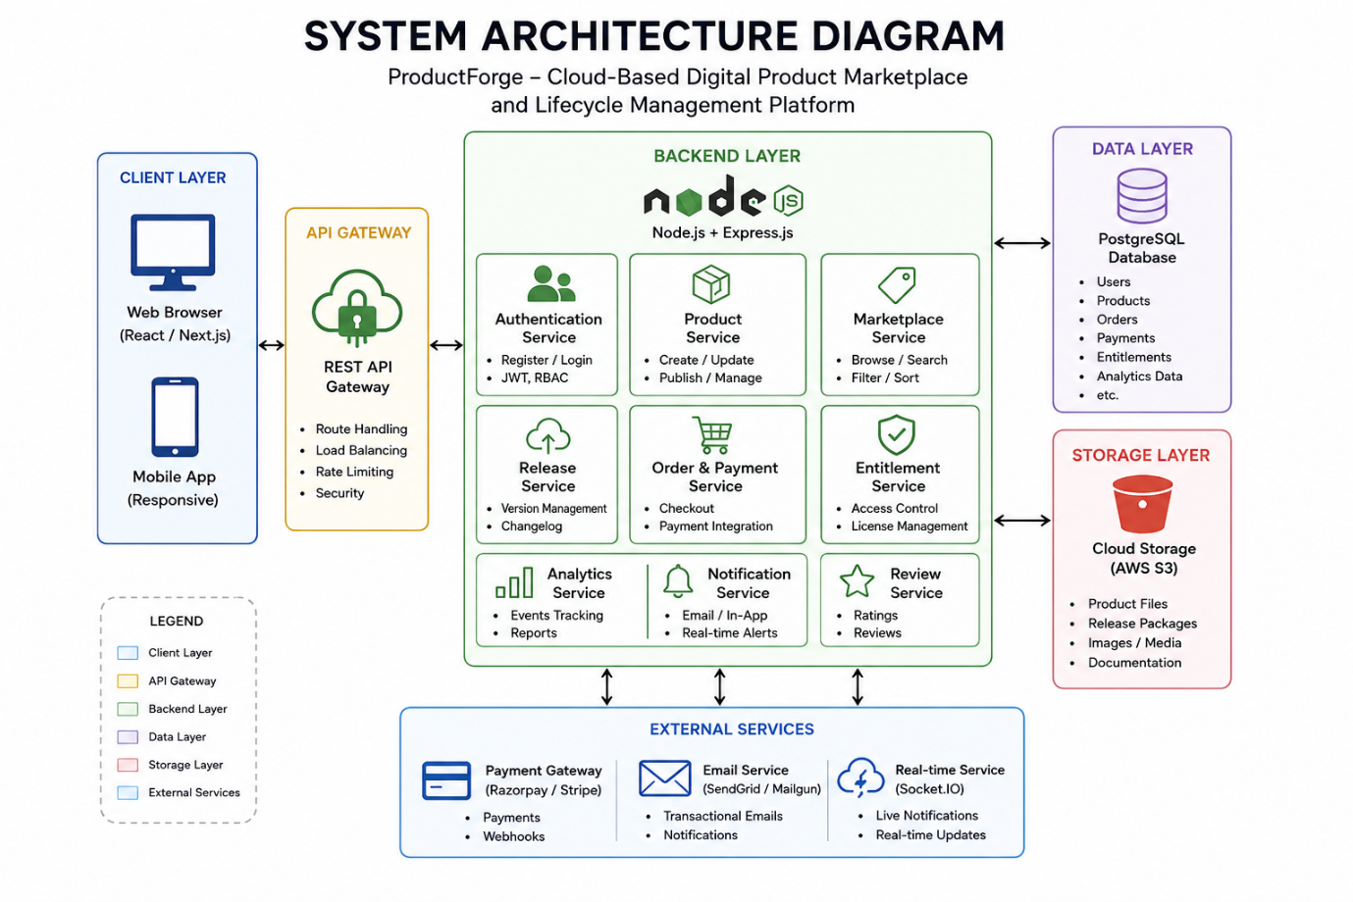
3.2 Detailed System Design
Client Layer
The client layer provides the graphical interface through which users interact with ProductForge. Different interfaces are presented according to the user's role.
The customer interface contains marketplace discovery, product details, purchases, product library, reviews, and account management.
The creator interface contains product creation, product management, release management, customer information, and analytics.
The administrator interface provides platform management functions.
API Layer
The API layer provides endpoints such as:
/api/auth
/api/users
/api/products
/api/releases
/api/orders
/api/payments
/api/entitlements
/api/reviews
/api/analytics
Requests are validated before being processed by the appropriate application module.
Authentication and Authorization Layer
The authentication system verifies user identity and generates authentication tokens after successful login.
Authorization middleware verifies whether the authenticated user has permission to perform the requested operation.
For example, customers can browse products, while only the creator who owns a product should be allowed to modify that product.
Business Logic Layer
The business logic layer handles operations such as product publication, order creation, release management, customer access, and lifecycle state changes.
Data Layer
The data layer communicates with PostgreSQL to store and retrieve structured information.
Storage Layer
The storage layer handles files associated with products and releases. Metadata about a file is maintained in the database, while the actual file is stored using object storage.
Real-Time Layer
The real-time layer can provide notifications for events such as new purchases or newly available product releases.

4. Database Design
ProductForge uses a relational database structure because the system contains multiple entities with clearly defined relationships.
The database stores structured application information, while product files and media are stored separately in object storage.

4.1 ER Diagram (Simplified)
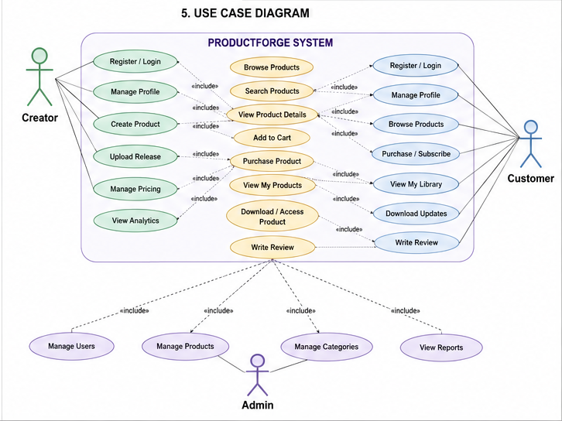

4.2 Relationships
User → CreatorProfile: A creator account can have one creator profile.
CreatorProfile → Product: One creator can manage multiple products.
Product → ProductVersion: One product can contain multiple releases or versions.
ProductVersion → ProductFile: One version can contain one or more associated files.
User → Order: One customer can create multiple orders.
Order → OrderItem: One order can contain multiple order items.
Product → OrderItem: A product can appear in multiple customer orders.
Order → Payment: An order can have associated payment information.
User → Entitlement: One user can have multiple product entitlements.
Product → Entitlement: One product can be accessible by multiple customers.
Therefore, customers and products effectively form a many-to-many relationship through the Entitlement entity.
Product → Review: One product can receive multiple reviews.
User → Review: One customer can review eligible products.

5. Data Flow Diagrams (DFD)
5.1 Level 0 DFD (Context Level)
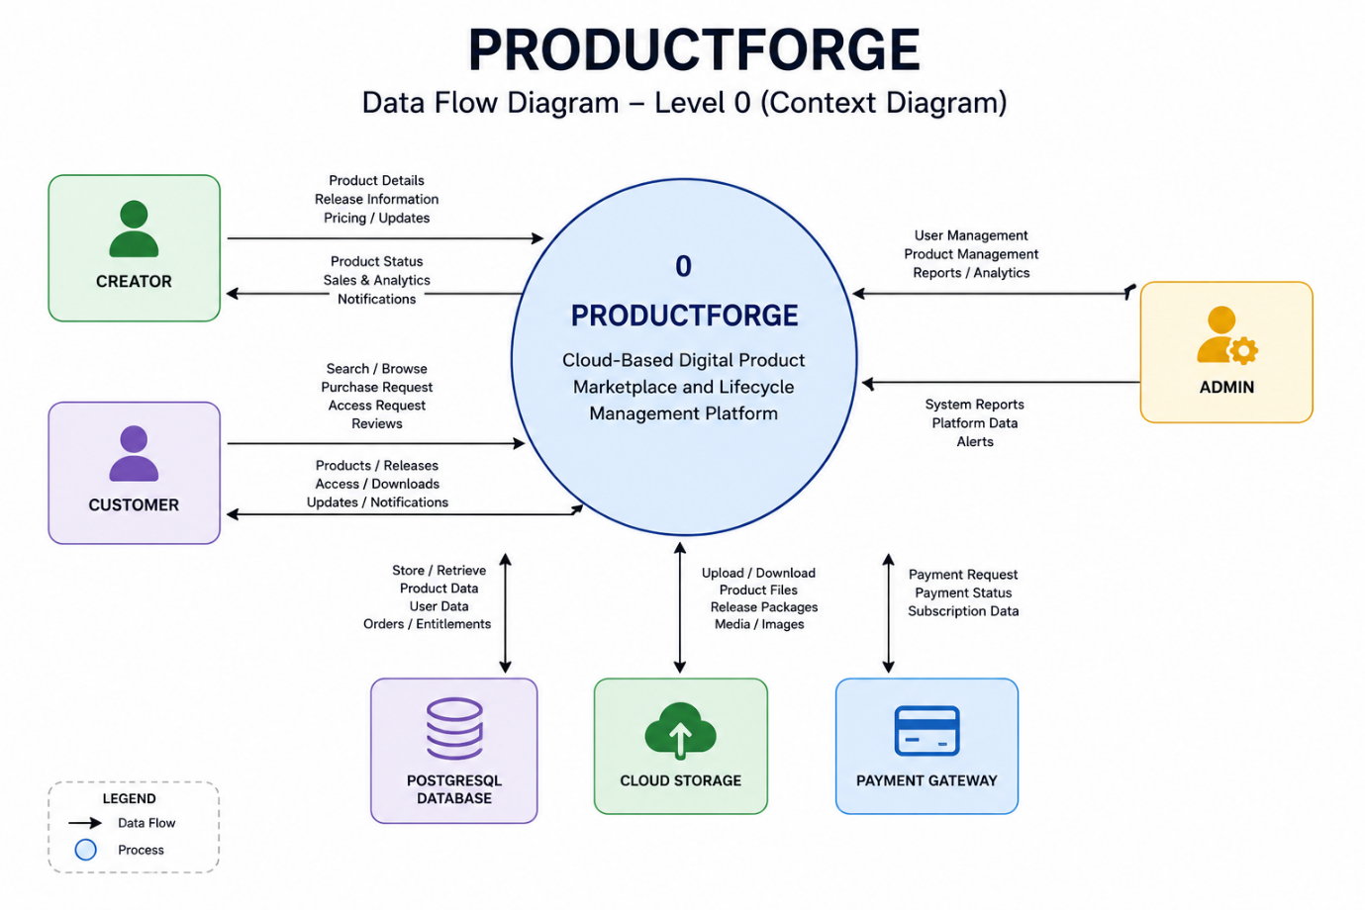

5.2 Level 1 DFD
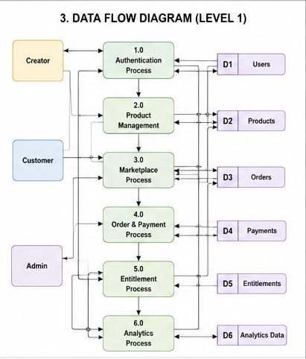
Process 1: Authentication
User → Registration/Login → Authentication Module → User Database
Process 2: Product Management
Creator → Product Details → Product Management → Product Database
Process 3: Marketplace
Customer → Search/Browse → Marketplace Module → Product Database → Product Results
Process 4: Release Management
Creator → Release Information/File → Release Module → Database + Cloud Storage
Process 5: Order and Payment
Customer → Checkout → Order Module → Payment Gateway → Payment Verification → Order Database
Process 6: Entitlement Management
Successful Order → Entitlement Module → Customer Product Access
Process 7: Reviews
Customer → Review → Review Module → Product Review Data
Process 8: Analytics
Platform Events → Analytics Module → Analytics Data → Creator Dashboard

6. Features Implemented
Feature | Description
User Registration/Login | JWT authentication system
Add Task | Users can create and assign deadlines
Edit/Delete Task | Task CRUD operations
Filter by Status | Toggle completed/pending
Responsive UI | Mobile and desktop compatibility

7. Screenshots
(Include pages like Login, Dashboard, Task Form, Filters, etc.)

8. Challenges Faced
Challenge | Solution
Token Expiry | Implemented refresh strategy
Form Validation | Used Yup + Formik
CORS | Handled via middleware

9. Future Enhancements
- Add tags/categories to tasks
- Push notifications
- Real-time collaboration
- Google OAuth login

10. Conclusion
ProductForge is designed as a cloud-based digital product marketplace and lifecycle management platform that provides creators with a centralized environment for managing software-based digital products. The platform addresses the fragmentation involved in using independent systems for product publishing, distribution, commerce, releases, customer access, and product management.
The proposed system extends the functionality of a conventional marketplace by maintaining the relationship between a product, its creator, its releases, its customers, and its commercial activity throughout the product lifecycle. Creators can create and publish products, manage product information, maintain multiple versions, distribute release files, manage customers, and monitor product activity. Customers can discover products, purchase or subscribe to them, access authorized releases, receive product updates, and provide feedback.
The project also demonstrates the practical integration of major full-stack development concepts including frontend development, backend API development, authentication, authorization, relational database design, cloud storage, external payment integration, real-time communication, and deployment.
The modular architecture of ProductForge allows additional functionality to be introduced without redesigning the complete system. Features such as advanced licensing, creator storefronts, organization accounts, API products, recommendation systems, enhanced analytics, and additional cloud services can be incorporated in future versions.
Overall, ProductForge aims to provide a structured and scalable ecosystem in which software products can be published, commercialized, distributed, updated, and managed continuously from a single platform, providing a unified experience for both creators and customers.

12. Appendix
- GitHub Repo: https://github.com/username/taskflow
- Live App: https://taskflow.vercel.app
- Postman Docs: Included in repository

